# INSIGHTS OF LOK SABHA ELECTIONS - 2024

## KEY INSIGHT 1: Top Parties by Total Votes

This insight reveals the political parties that received the highest total votes across all constituencies. It helps to identify the most popular and influential parties in the election. The data shows the sum of votes for each party and ranks them to highlight the top 10 parties.The Bharatiya Janata Party (BJP) and the Indian National Congress (INC) continue to dominate the political landscape, securing the majority of votes across multiple states. This trend indicates a strong preference for national parties over regional parties.  
  
Let’s see the winning party across each state and the party that dominated the most across India.  
  
The link to the Winning Party List is provided here: Winning parties by state

## Top Parties by Total Votes

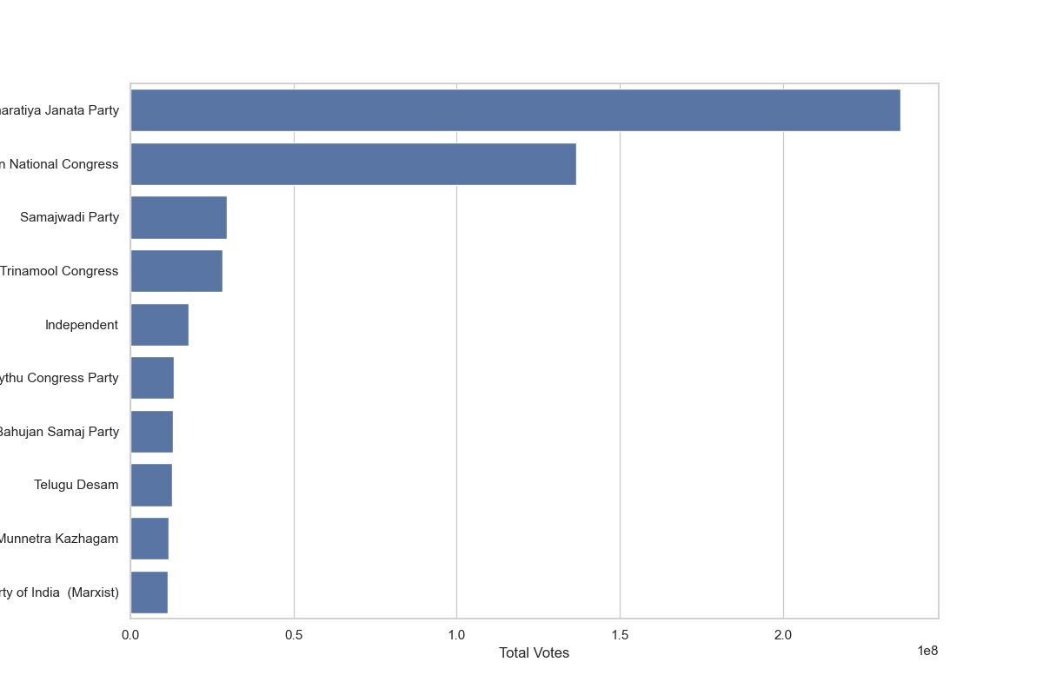

## KEY INSIGHT 2: Candidates with Highest Votes

This insight lists the candidates who received the highest number of votes in the election. It highlights the top-performing candidates and their respective parties.Even though BJP won with the highest number of votes, the candidate who received the highest number of votes is RAKIBUL HUSSAIN from Indian National Congress

## Candidates with Highest Votes

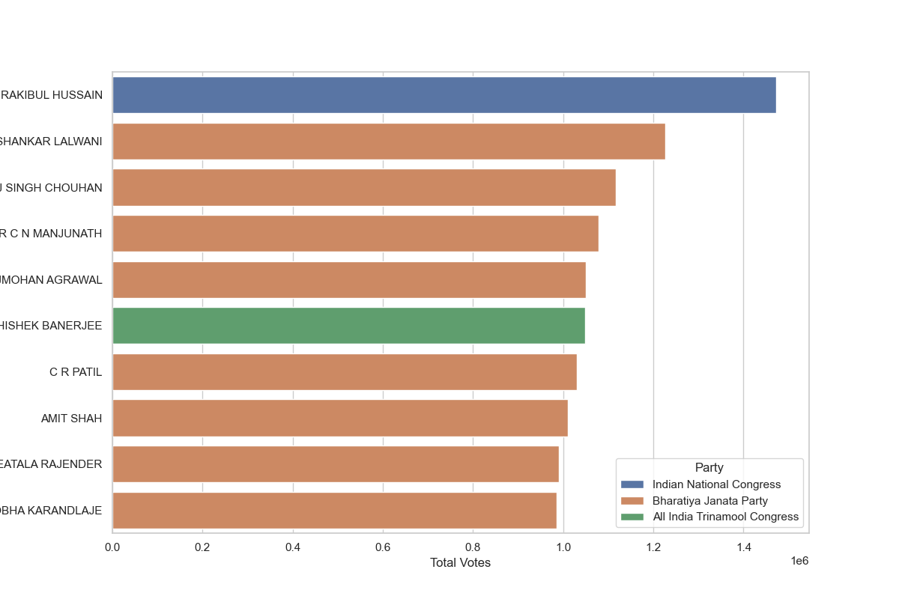

## KEY INSIGHT 3: Constituencies with Highest Voter Turnout

This insight identifies the constituencies that had the highest voter turnout.It shows the sum of votes for each constituency and ranks them to highlight the top 10 constituencies.

## Constituencies with Highest Voter Turnout

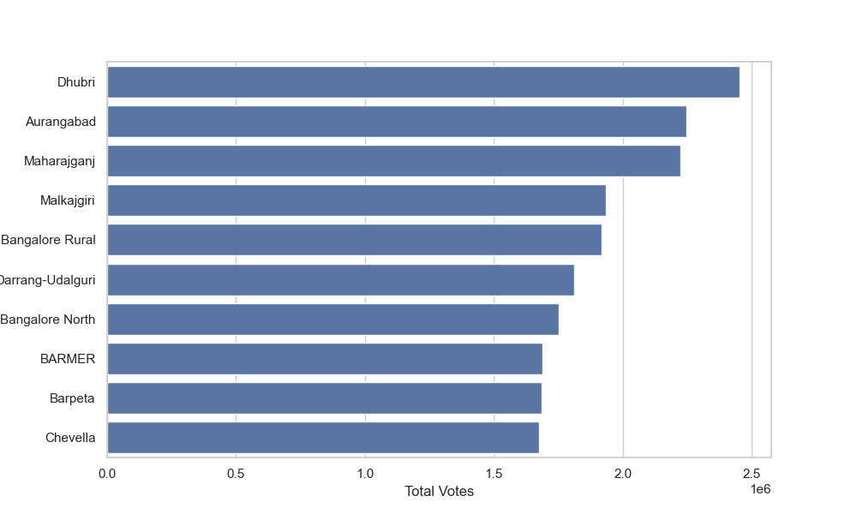

## KEY INSIGHT 4: State-wise Distribution of Votes

This insight provides a state-wise distribution of total votes. It shows the sum of votes for each state, helping to understand the geographical spread of voter support.

## State-wise Distribution of Votes

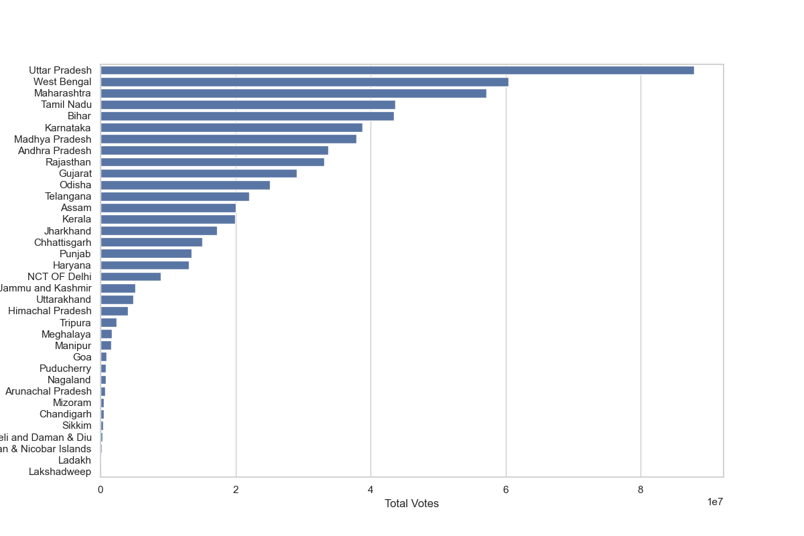

## KEY INSIGHT 5: Winning Margins

This insight calculates the winning margins for candidates, showing the difference between the votes received by the winning candidate and the runner-up. It lists the top 10 candidates with the highest winning margins.

## Winning Margins

|  |  |  |  |
| --- | --- | --- | --- |
| Constituency Name | Candidate | Total Votes | Winning Margin |
| Dhubri | TAHIDUR RAHMAN | 5392.0 | 1012476.0 |
| Dhubri | NOTA | 15015.0 | 1012476.0 |
| Dhubri | HAFIZ BURHANUDDIN | 6940.0 | 1012476.0 |
| Dhubri | RADHARANI BISWAS | 6287.0 | 1012476.0 |
| Dhubri | FARUK KHAN | 10994.0 | 1012476.0 |
| Dhubri | SHUKUR ALI | 4792.0 | 1012476.0 |
| Dhubri | S. M. JIAUL HAQUE | 12106.0 | 1012476.0 |
| Dhubri | ZABED ISLAM | 438594.0 | 1012476.0 |
| Dhubri | MOHAMMED BADRUDDIN AJMAL | 459409.0 | 1012476.0 |
| Dhubri | SURAT ZAMAN MONDAL | 4015.0 | 1012476.0 |

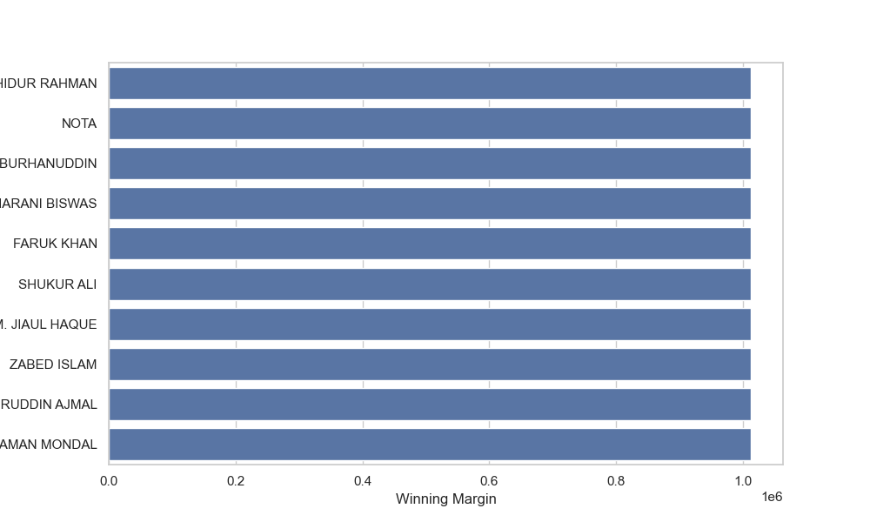

## KEY INSIGHT 6: Correlation between EVM and Postal Votes

This insight examines the correlation between votes received through Electronic Voting Machines (EVMs) and postal votes. A correlation coefficient is calculated to show the relationship between these two variables.This metric helps in understanding the relationship between different voting methods.A strong correlation might indicate consistency in voter preferences across different voting methods.

## Correlation between EVM and Postal Votes

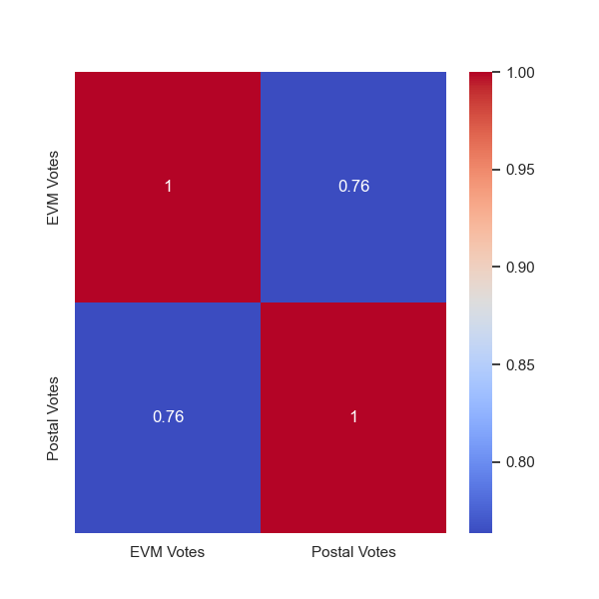

## KEY INSIGHT 7: Distribution of Vote Percentages

This insight provides a statistical summary of the distribution of vote percentages among candidates. It includes metrics like mean, median, and standard deviation.This metric helps in understanding the overall competitiveness of the election.It shows how vote percentages are distributed among candidates, indicating whether the votes are concentrated among a few candidates or spread out.

## Distribution of Vote Percentages

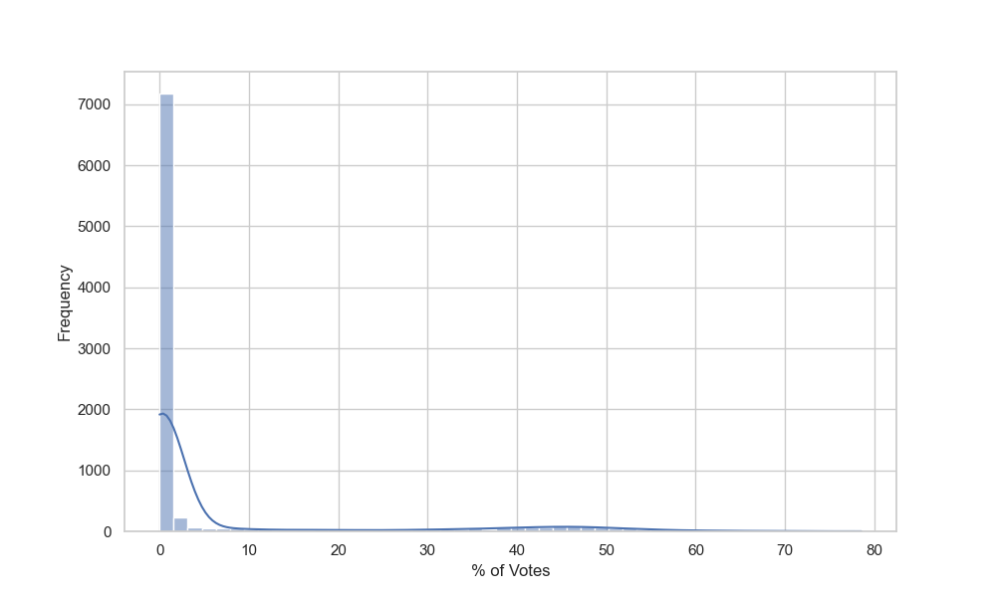

## KEY INSIGHT 8: Top States by Number of Candidates

This insight lists the states with the highest number of candidates contesting in the election. It shows the count of candidates for each state and ranks them to highlight the top 10 states.This metric helps in understanding the level of political competition in different states.A higher number of candidates might indicate more political diversity and competition.

## Top States by Number of Candidates

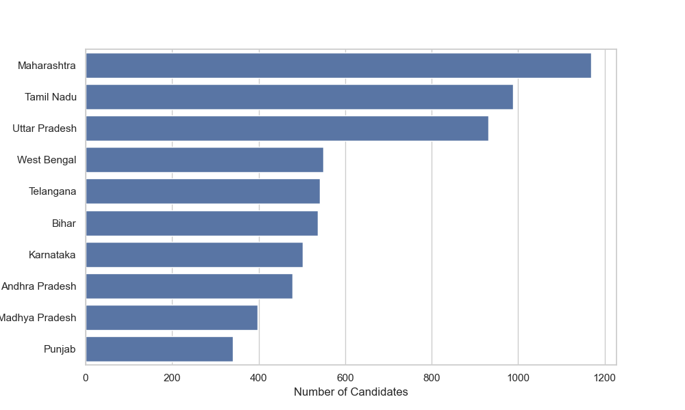

## KEY INSIGHT 9: Party Performance in Different States

This insight provides a detailed view of how different political parties performed across various states. It shows the total votes received by each party in each state.This metric is crucial for understanding the regional strengths and weaknesses of different parties.It helps in identifying which parties are dominant in specific states.

## Party Performance in Different States

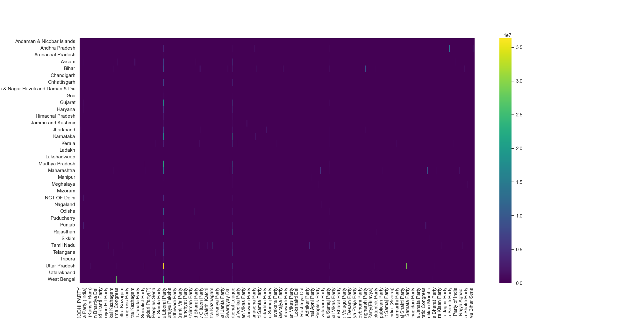

## KEY INSIGHT 10: Analysis of Independents

This insight focuses on the performance of independent candidates. It lists the top states where independent candidates received the highest total votes.This metric helps in understanding the support for non-affiliated candidates.It shows regions where voters prefer independent candidates over party-affiliated ones.

## Analysis of Independents

